Nuxeo – SAP Commerce Cloud
Connector

Installation and Configuration Instructions
User Manual

Contents

Introduction 3
Installation of the Nuxeo Package 3
Registered Instance 3
Unregistered Instance 3
Installation of the SAP Commerce packages 4
SAP Commerce CLOUD 4
SAP Commerce (managed installation) 4
Activating the Connector 4
Configuring your Nuxeo Platform 5
Configuring you SAP Commerce Platform 5
Configuration of the Nuxeo Connection 5
Nuxeo Groups 6
Nuxeo Authentication 6
Features 7
Upload a local file to Nuxeo and SAP Commerce 7
Assign an existing Nuxeo reference to an attribute in SAP Commerce 9
Multiple Files Upload 11
Type-wide Migration 11
Support 13

Introduction

The SAP Commerce to Nuxeo Connector is composed of two parts: a Nuxeo package that enables public viewing and downloading of Nuxeo publications from outside sources, and a set of SAP Commerce extensions that allows SAP Commerce to use Nuxeo as an integrated media management platform.

The Nuxeo package element can be acquired from the Nuxeo Marketplace at (https://connect.nuxeo.com/nuxeo/site/marketplace). Just search for “SAP Commerce Connector”, and follow the link to find the required introductory information and understand how to purchase the software.
The SAP Commerce package for the Connector is comprised of 3 SAP Commerce Extensions. These are:

- nuxeoconnectoradapter
- nuxeoconnectorcore
- nuxeoconnectorbackoffice

The extensions can be obtained by contacting Sales in Philos IT. See https://www.philos-it.com/sap-commerce-nuxeo-connector/ or email sales@philos-it.com to request additional information.

Installation of the Nuxeo Package

There are two ways to install the Nuxeo package:

Registered Instance

To install the package on a registered instance, execute the following command:

$NUXEO_HOME/bin/nuxeoctl mp-install sap-commerce-connector.zip

Unregistered Instance

In order to install the package on an unregistered instance, you need to:

- Download the package
- Stop your Nuxeo Instance
- Execute the following command:
$NUXEO_HOME/bin/nuxeoctl mp-install /path/to/sap-commerce-connector.zip

Installation of the SAP Commerce packages

There are two ways to install the three extensions that are needed in SAP Commerce.

SAP Commerce CLOUD

In case of a SAP Commerce CLOUD installation

- Log into you SAP Portal installation
- Change the manifest.json file and include the following lines.

"extension" : "nuxeoconnectoradapter",
"extension" : "nuxeoconnectorcore",
"extension" : "nuxeoconnectorbackoffice",

SAP Commerce (managed installation)

If you have an in-house managed installation, you can install the connector by:

- Moving the SAP Commerce extensions to the custom folder that contains your proprietary extensions
- Edit the localextensions.xml file (residing in the config folder) by adding the following lines.

<extension name='nuxeoconnectoradapter' />
<extension name='nuxeoconnectorcore' />
<extension name='nuxeoconnectorbackoffice' />

Activating the Connector

Regardless of the location of your SAP Commerce distribution (i.e. Cloud or On-premise), in order to activate the extensions, do the following:

- stop your SAP Commerce instance
- Build your instance using ant clean all
- Start your server
- Execute an Update operation (Update Running System)
- Restart your SAP Commerce instance

Your instance should be ready.

Configuring your Nuxeo Platform

In order to enable the viewing of the Nuxeo documents from external sources, ensure that you system has a user called “sap-user”. In order to do so, follow the steps provided in the following link https://doc.nuxeo.com/userdoc/administration/.

No additional configuration is required on Nuxeo.

Configuring you SAP Commerce Platform

Configuration of the SAP Commerce platform requires several steps. We will list them in the following section.

Configuration of the Nuxeo Connection

In order to configure the Nuxeo Connection an instance of NuxeoConnection has to be created. Currently, the system supports only one Nuxeo Connection configuration at a time.

To do so:
- Log into the Backoffice of your instance
- Search for the “Nuxeo Connection” type in the explorer tree
- Create a new instance by clicking on the plus (+) icon
- Fill the required fields and Save the instance.

In order for the instance to be saved, the following fields must be filled:

- Code: a unique code that identifies the connection
- Endpoint: the address of the Nuxeo instance.
- Workspace Root: the root folder which will be used for storing documents in Nuxeo
- Publishing Root: the name of the Section used of the Nuxeo Publications

In order for the connector to work correctly, all four fields must be filled correctly.

Alternatively, the connection can be set up using the following Impex script:

INSERT_UPDATE NuxeoConnection;code[unique=true];endpoint;workspaceRoot;publishingRoot;
;localhost;http://nuxeo.environment:8080/nuxeo;/default-domain/workspaces/workspace;Output;

Nuxeo Groups

In order to enable the usage of SAP Commerce Backoffice features, the user has to set up two user groups with the following codes: nuxeobrowsegroup (for browsing of Nuxeo Publications and assignment) and nuxeouploadgroup (to upload files to Nuxeo from the Backoffice).

To add User Groups to the SAP Commerce instance, you need to:

- Log into the Backoffice of your instance
- Search for the “User Groups” type in the explorer tree
- Create a new instance by clicking on the plus (+) icon
- Fill the “uid” field and Save the instance.

These groups enable Backoffice functionalities and can be assigned to singular users and other User Groups alike.

Here is a sample script assigning these groups to the Administration Group.

INSERT_UPDATE UserGroup;uid[unique=true];
;nuxeobrowsegroup
;nuxeouploadgroup
UPDATE UserGroup;uid[unique=true];groups(uid)[node=append];
;admingroup;nuxeobrowsegroup,nuxeouploadgroup

Nuxeo Authentication

In order to match a SAP Commerce profile with a Nuxeo profile, an instance of Nuxeo Authentication must be created and assigned to a user (or user group) in the system.

In order to do so:
- Log into the Backoffice of your instance;
- Search for the “Nuxeo Authentication” type in the explorer tree;
- Create a new instance by clicking on the plus (+) icon;
- Fill the required fields and Save the instance;
- Navigate to the User/User Group you want to assign the Authentication to;
- Navigate to the “Nuxeo” tab;
- Assign the Authentication reference to the User/User Group.

The following fields have to be set:

- Code: a unique code that identifies the authentication;
- User: the Nuxeo user;
- Password: Nuxeo password;
- Endpoint: the address of the authentication server of the Nuxeo credentials.

This can be easily done using the following Impex Script:

INSERT_UPDATE NuxeoAuthentication;code[unique=true];endpoint;user;password;
;localhost;http://nuxeo.environment:8080/nuxeo;user;password

Features

Upload a local file to Nuxeo and SAP Commerce

In order to Upload a file from your local system to Nuxeo through SAP Commerce Backoffice, please follow the steps below:
- Log into your SAP Backoffice Instance
- Search for “Upload a local file in Nuxeo” in the left-side explorer tree
- In the first page of the wizard, upload your desired media through the editor by either drag-and-drop or your system’s file selector.
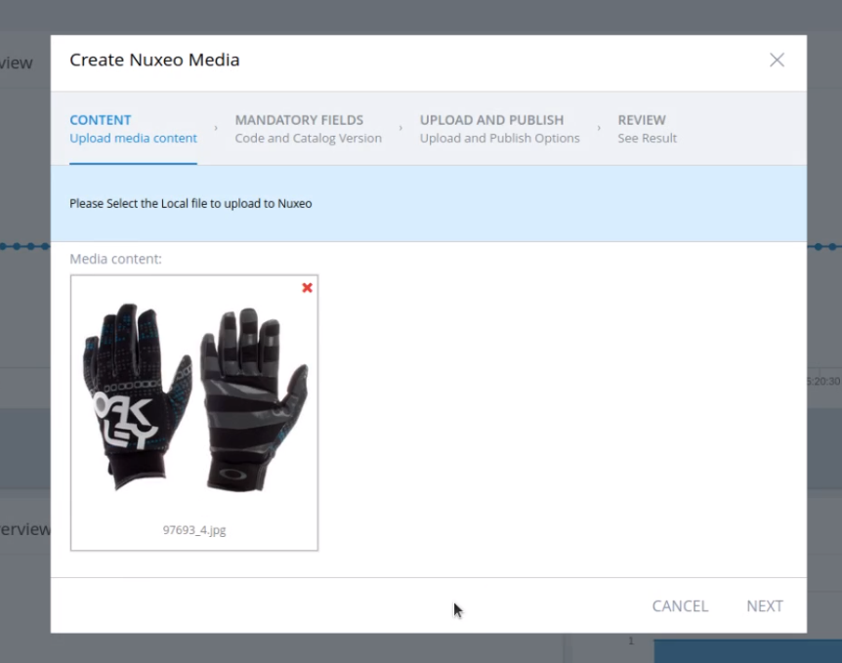
- In the second page of the wizard, select the unique code (identifier) and Catalog Version in which the SAP Commerce reference will reside.
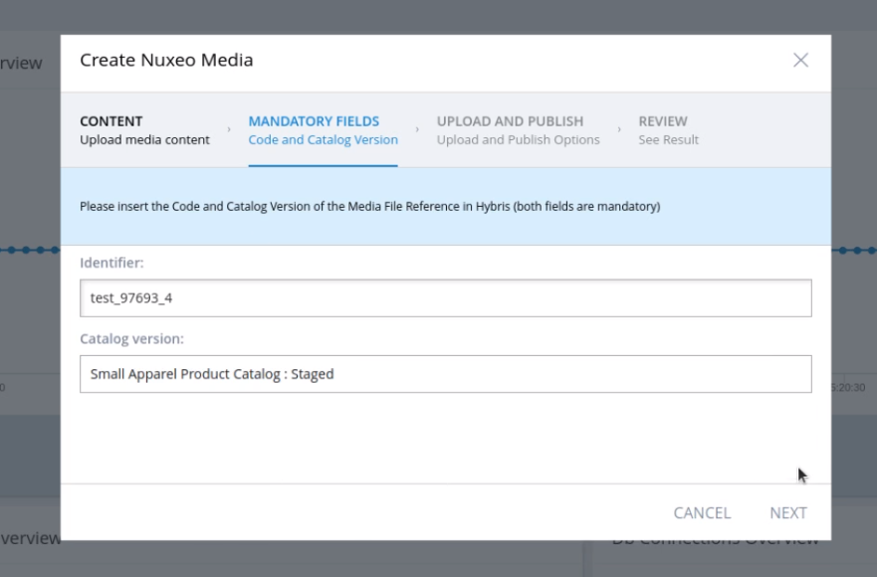
- In the third page of the wizard, you can add tags (which will be added to the file in Nuxeo), the destination folder in which the Nuxeo file will be saved and the Publishing Formats (which will produce Publications in Nuxeo). Clicking on “Next” will start the Upload and Publishing process.
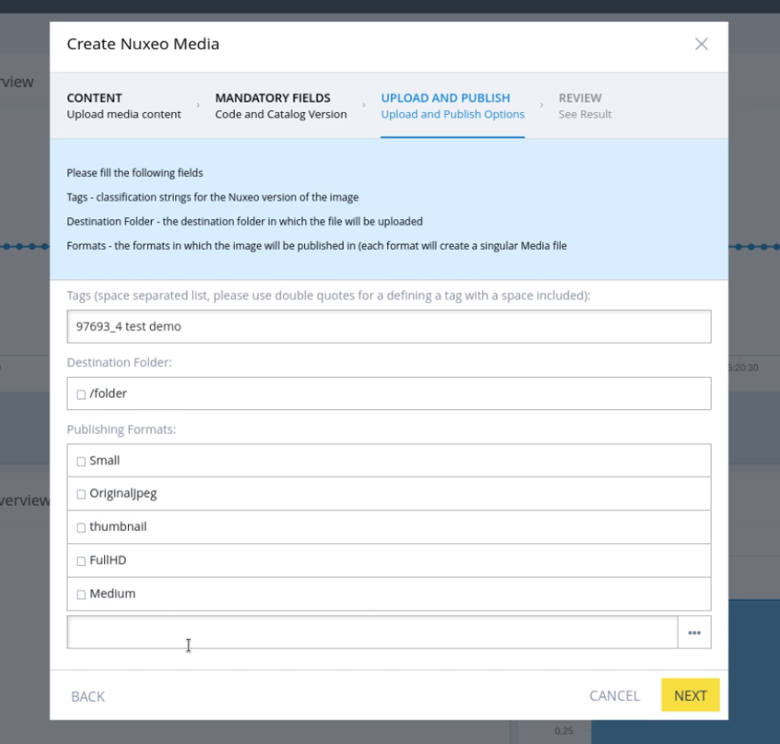
- In the last page, you can review the result SAP Commerce Media (which contains Nuxeo references)
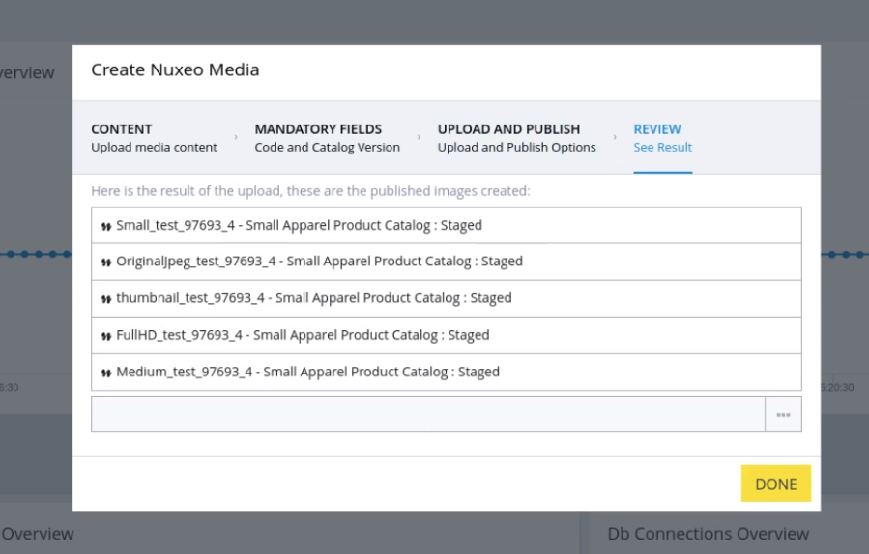

Assign an existing Nuxeo reference to an attribute in SAP Commerce

You can assign an existing Nuxeo Published Document to a Media attribute in SAP Commerce.
- Log into your SAP Backoffice Instance.
- Select an item (CMS item, Product, …) and navigate to the Media-type attribute which you want to set up with a Nuxeo. For example, you can select a Product and navigate to the “Multimedia” panel.
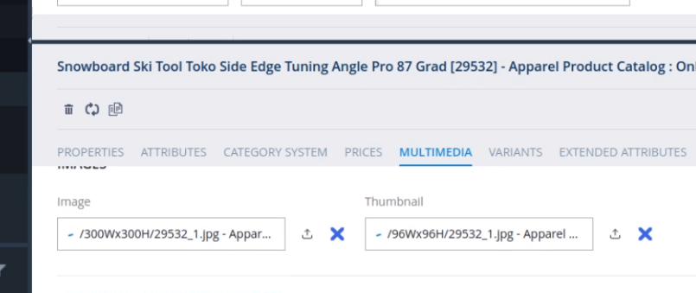
- You will notice that there is a Nuxeo icon appearing on the side of Media type attributes, click on the icon to open the Nuxeo Document Browser
- In the browser window you can search for your desired document, either by document ID or name.
- In the result list, preview and select the desired document(s).
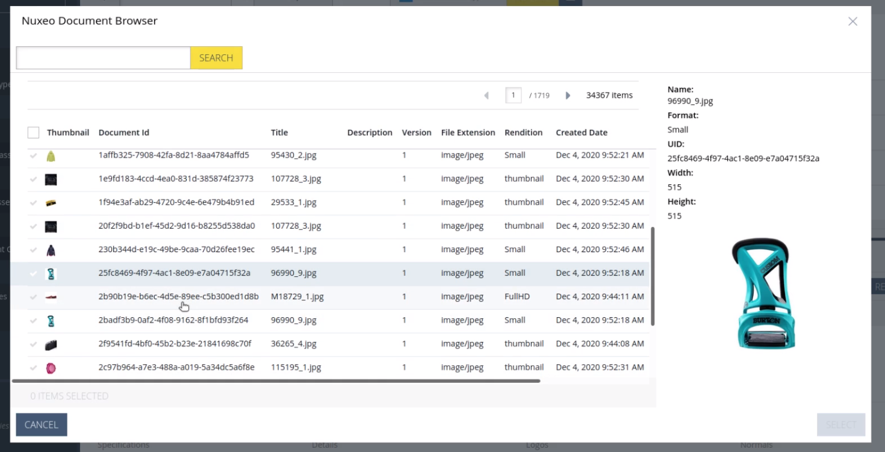
- Once you found the desired document, select it by clicking on the selection tick on the left side of the result table.
- Click on select and you will notice that the selected document will be assigned to the Media attribute linked to the browser.
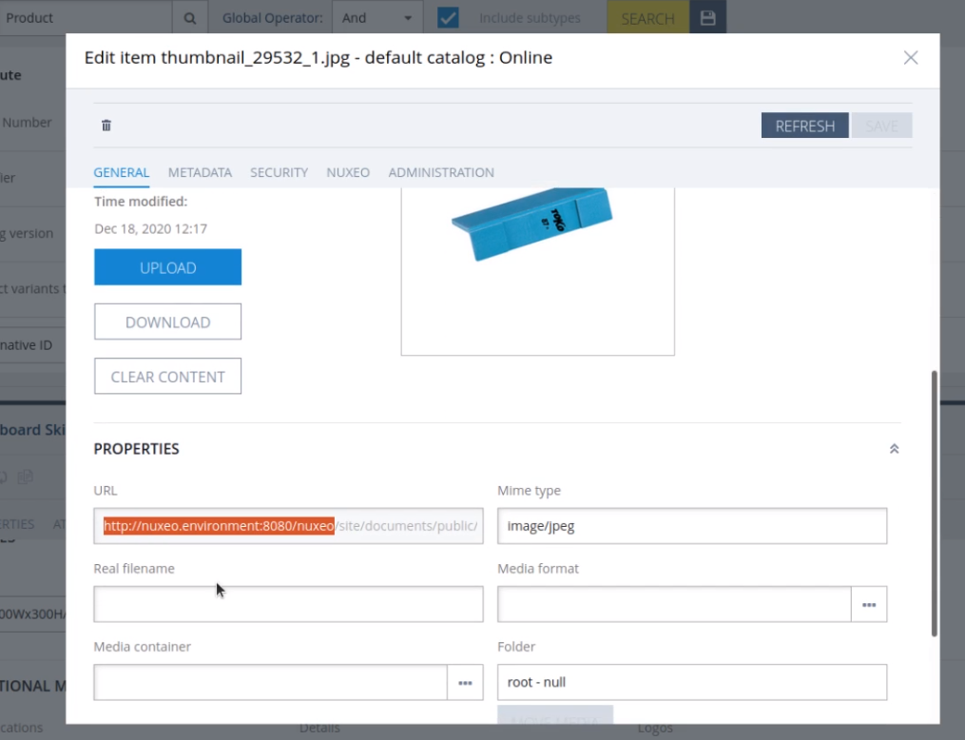

Multiple Files Upload

You can upload multiple existing documents to Nuxeo by following the steps below:
- Log into your SAP Backoffice Instance
- Search for “Multiple Files Upload to Nuxeo” in the explorer tree
- After opening the wizard, select the Media instances to upload to Nuxeo, click on “Next” when all the medias have been selected
- In the second window, fill the form with the desired Tags and the format desired for the publication. Click “Next”.
- The program will create a new cronjob which will asynchronously upload the data, you can review the cronjob by double clicking on it.

Type-wide Migration

The main way to migrate media from SAP Commerce into Nuxeo is by using the “Migration by Type” functionality. Through this functionality, the user can select the references of a given type (Product, CMS Item, etc.) and upload them in bulk.
- Log into your SAP Backoffice Instance
- Search for “Migrate Media to Nuxeo By Type” in the explorer tree
- In the first page of the wizard, select the desired Type and the Catalog Version. Click “Next”
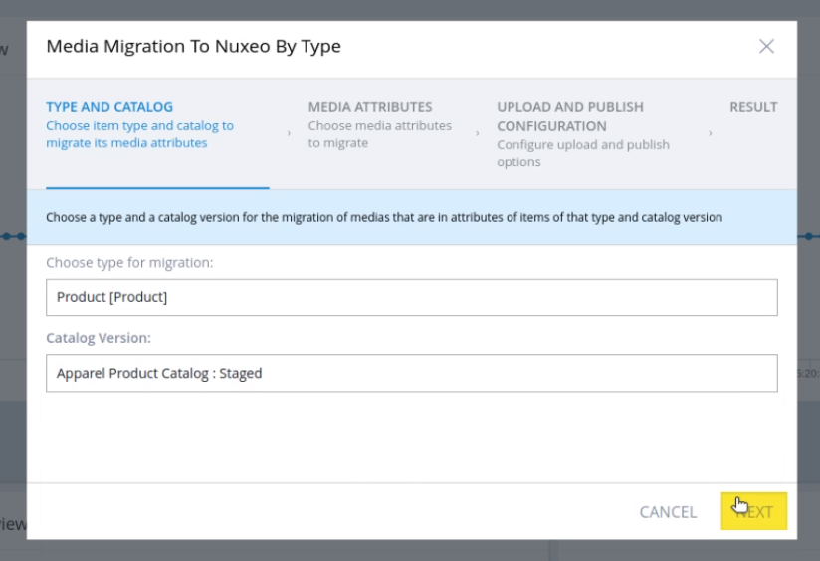
- In the second page of the wizard, you can select the attributes to migrate (the list will be limited to Media and MediaContainer type attributes), which fields will be used as Name of the file and tags and the localization languages.
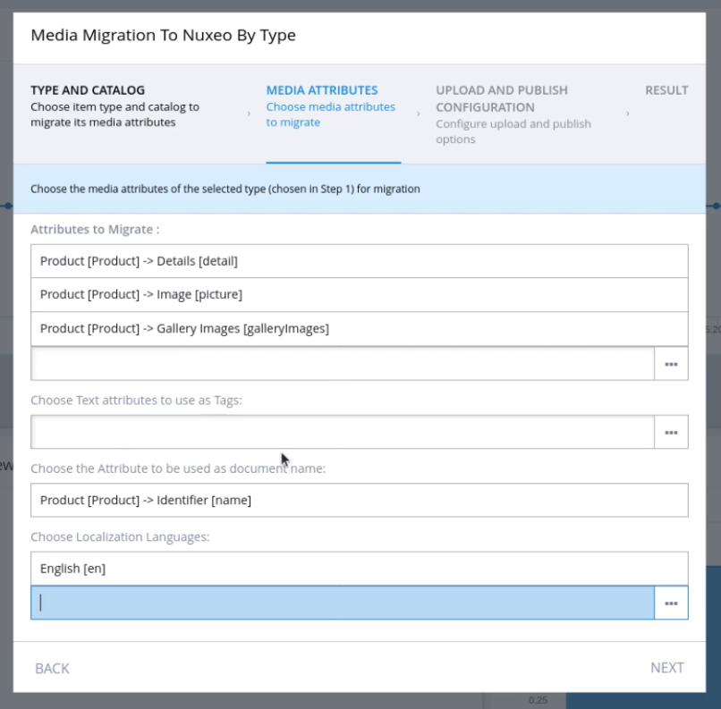
- In the third page of the wizard, you can select the type of mapping (by-type or by-attribute), the Format Mappings (depending on the type of Migration) and the Destination Folder (in Nuxeo) in which the files will be saved (make sure the folder exists in Nuxeo). Click on “Next”.
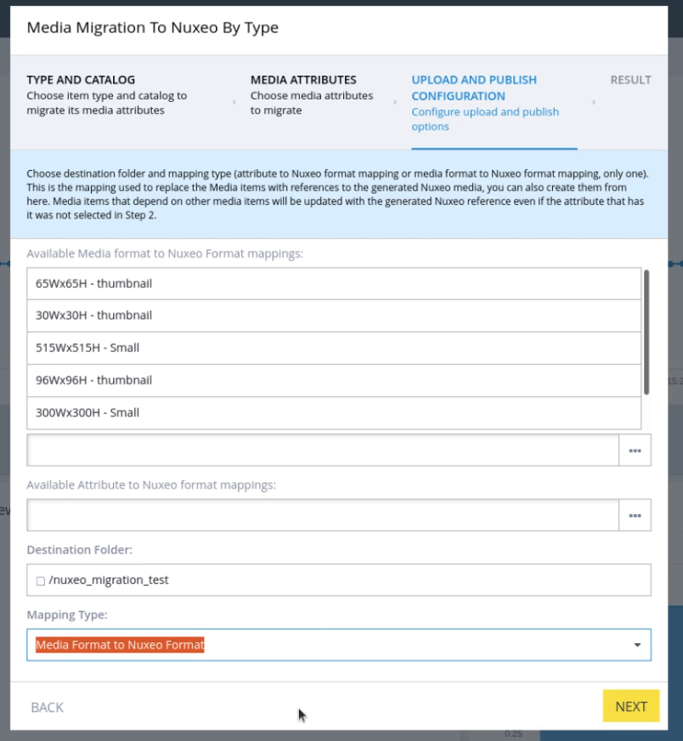
- In the Result page, you can view the result cronjob which will run in the background and execute the migration. You can review the cronjob and the failed uploads in the cronjob
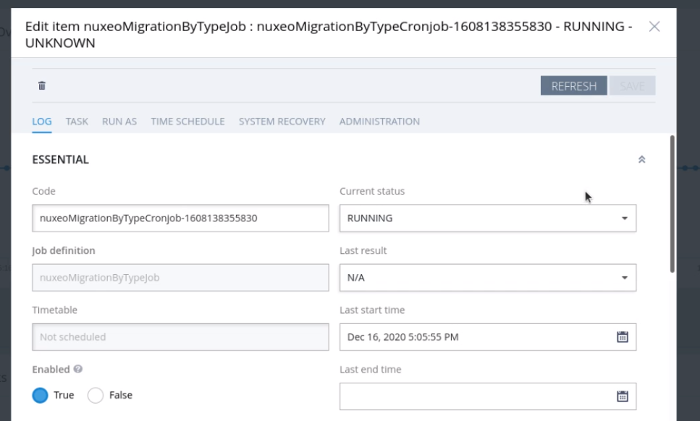

Support
If you require additional support or assistance, then please contact support@philos-it.com and we will be delighted to help you!!

